**Store Layout Management**

**Preconditions:**

* The user is logged into the system.

**Main Flow:**

* The store owner navigates to the store layout management.
* The system set up the grid and display the component palette and canvas.
* The store owner drags a component from the palette to the canvas.
* The system snaps the component to the grid.
* The store owner selects a component to move or resize.
* The system applies the changes.
* The store owner saves the current layout.
* The system saves the layout.
* If the store owner wishes to update the layout, they select components on the canvas to move, resize or delete, then save changes.
* The system applies the changes and saves the layout in the database.
* If the store owner wishes to delete the layout, they select the delete option.
* The system prompts the store owner for confirmation.
* Upon confirmation, the system removes the layout from the database and clears the canvas.

**Alternative Flows**

1. **Undo/Redo Actions**

* User can undo or redo actions using the toolbar.
* The layout state is reverted or advanced accordingly.

1. **Adjust Grid Size**

* User changes the grid size via the toolbar.
* Components snap to the new grid size.

**Error Flows**

1. **Component Collision:**

* If a component is placed on top of another, the system displays an error message prompting the user to reposition the item.

1. **Boundary Exceeded:**

* If a component is moved outside the canvas bounds, the system displays an error message and prompts the user to reposition it within bounds.

1. **Invalid Operation:**

* If the user attempts an invalid action (e.g., resizing below minimum size), an error message is shown, and the action is prevented.

1. **Save Error:**

* If a save operation fails (e.g., due to a server error), the system notifies the store owner and prompts them to retry or check their connection.

1. **Delete Confirmation Error:**

* If a layout delete confirmation is canceled or an error occurs during deletion, the system retains the layout in its current state, and the user is notified.

**Postconditions:**

* The layout is saved and can be retrieved later.
* The editor reflects the latest changes.

**Activity Diagram:**

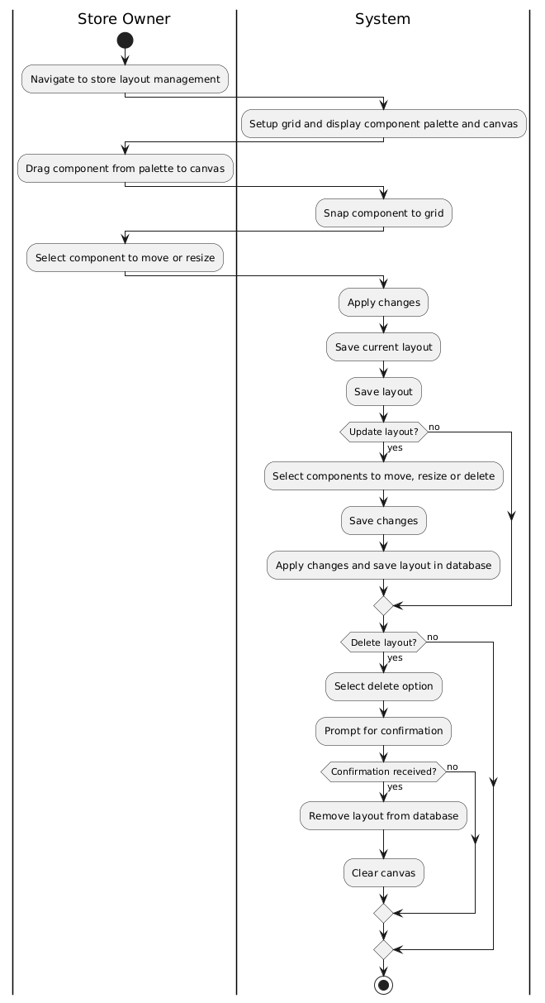

**Sequence Diagram:**

